

School of Computer Science & Engineering

Project Work

Winter Semester 2025-2026

Programme: B. Tech
Branch: Computer Science and Engineering (Information Security)
Course Code: BCSE203E
Course Name: Web Programming
Faculty Name: Prof. Komathy C
Student Name: Mridul Kishanpuria
Registration No.: 24BCI0183
Date of Submission: 02/04/2026

Abstract
VITEvents is a sleek, responsive, and centralized web application designed to streamline the discovery, registration, and management of campus events at VIT Vellore. Moving away from fragmented communication channels, this portal provides a unified interface for students to browse Technical, Cultural, Sports, and Academic events. Built utilizing HTML5, CSS3, and Vanilla JavaScript with a lightweight Google Apps Script backend, the system features real-time filtering, dynamic modal-based registration, an event proposal system for clubs and chapters, and an inclusive dark/light mode UI. The project successfully demonstrates the application of modern frontend web programming principles to solve a practical campus administration challenge.

Table of Contents
- Introduction .......................................................................... 3
  - Project overview
  - Problem statement
  - Objectives
- Literature Survey .................................................................. 4
  - Related work / existing systems
- System Analysis .................................................................... 5
  - Existing system
  - Proposed system
  - Advantages
- System Design ....................................................................... 6
  - Data flow diagram (DFD)
- Implementation ..................................................................... 7
  - Tools & technologies used
  - Modules explanation
  - Code snippets
- Results / Output Screens ...................................................... 9
- Conclusion ............................................................................. 11
- Future Scope ......................................................................... 12
- References ............................................................................. 13

Introduction
Project Overview VITEvents is a dedicated campus event platform tailored for the vibrant ecosystem of VIT Vellore. It serves as a bridge between event organizers (clubs, chapters, and departments) and the student body. The platform dynamically renders events, allows students to register with their VIT credentials, and provides an admin dashboard to track metrics.
Problem Statement: Currently, information regarding campus fests (like Gravitas and Riviera), workshops, and club events is scattered across various WhatsApp groups, emails, and physical notice boards. Students often miss out on opportunities due to fragmented communication, and event organizers struggle with managing registrations through unorganized Google Forms.
Objectives:
- To develop a centralized, mobile responsive web portal for all campus events.
- To implement a seamless, modal-based user authentication and registration flow.
- To provide clubs and student chapters with an automated "Event Proposal" pipeline.
- To ensure high accessibility through a dual-theme (Light/Dark) Material/Spotify-inspired interface.

Literature Survey

Related Work / Existing Systems Most current campus event registrations rely heavily on third-party form builders (like Google Forms or Typeform) distributed via social media. While the VTOP portal handles academic functions securely, it lacks a dedicated, aesthetically engaging discovery module for extracurricular events. Platforms like Eventbrite exist globally but are not tailored to internal university ecosystems requiring specific registration numbers and institutional email validation.

System Analysis
Existing System
- Manual tracking of registrations via standalone spreadsheets.
- Lack of unified categorization (Technical, Cultural, Sports).
- No real-time indication of event capacity or availability.
Proposed System
- A single-page application (SPA) feel using Vanilla JavaScript to dynamically filter and load events.
- An integrated Google Apps Script (GAS) backend that directly securely pipes registration and proposal data into centralized Google Sheets.
- An Admin Dashboard (admin.html) secured by a password to monitor incoming data streams in real-time.
Advantages
- Centralized Discovery: All events in one searchable, filterable grid.
- Frictionless UX: Registration happens in-place via modals without redirecting the user.
- Zero-Cost Backend: Leveraging Google Workspace for database management ensures 100% uptime with zero hosting costs.

System Design
Data Flow Diagram (DFD)
- User Request: The student opens index.html.
- Frontend Rendering: script.js loads the event array and renders the DOM elements.
- Action (Registration/Proposal): User fills out a modal form. Client-side validation ensures VIT email formats and 10-digit phone numbers are correct.
- API Call: A POST request is sent via JavaScript fetch() to the deployed Google Apps Script URL.
- Data Storage: gas_code.gs catches the payload, parses the JSON, and appends a new row to either the "Registrations" or "Proposals" Google Sheet.
- Admin Access: The Admin logs into admin.html, which triggers a GET request to fetch and display the CSV output of the Google Sheets.

Implementation
Tools & Technologies Used
- Frontend: HTML5, CSS3 (Custom Variables for Theming), Vanilla JavaScript (ES6+).
- Backend: Google Apps Script (GAS).
- Database: Google Sheets (CSV Endpoint Integration).
- Assets: FontAwesome Icons, Unsplash Images.
Modules Explanation
- Theme Engine: Toggles CSS variables between a clean Material light mode and a Spotify-inspired dark mode, saving preferences in localStorage.
- Dynamic Event Grid: Uses array filtering to update the DOM based on category dropdowns and search bar inputs.
- Modal System: Custom-built modal overlays for Login, Signup, Event Proposal, and Event Registration, keeping the user context on the main page.
- Admin Dashboard: A separate interface that parses raw CSV data from published Google Sheets into a clean HTML table format for organizers.
Code Snippets
1. Google Apps Script Backend (gas_code.gs)
JavaScript
function doPost(e) {
try {
const data = JSON.parse(e.postData.contents);
const sheet = SpreadsheetApp.openById("YOUR_SHEET_ID")
.getSheetByName(data.type === 'proposal' ? 'Proposals' : 'Registrations');

const row = [ new Date(), data.type, data.name || data.eventName || '', data.email || '' /* ... */ ];
sheet.appendRow(row);

return ContentService.createTextOutput(JSON.stringify({ success: true }))
.setMimeType(ContentService.MimeType.JSON);
} catch (err) { ... }
}
2. Client-Side Theme Toggle (script.js)
JavaScript
themeToggle.addEventListener("change", function () {
if (this.checked) {
document.body.classList.add("dark-mode");
localStorage.setItem("theme", "dark");
} else {
document.body.classList.remove("dark-mode");
localStorage.setItem("theme", "light");
}
});

Results / Output Screens

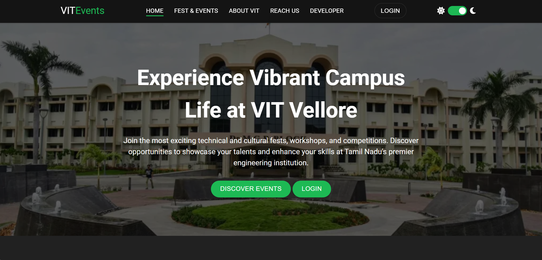
Screenshot of the Hero Section displaying the Dr. M.G.R. Block
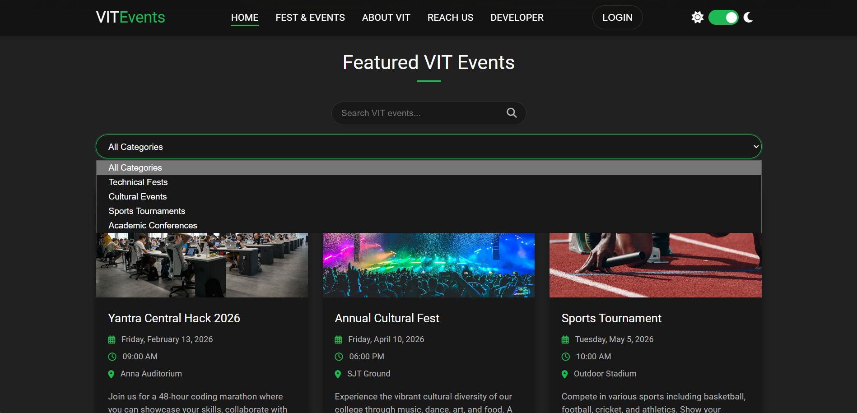
Screenshot of the Featured Events Grid and Search Filter
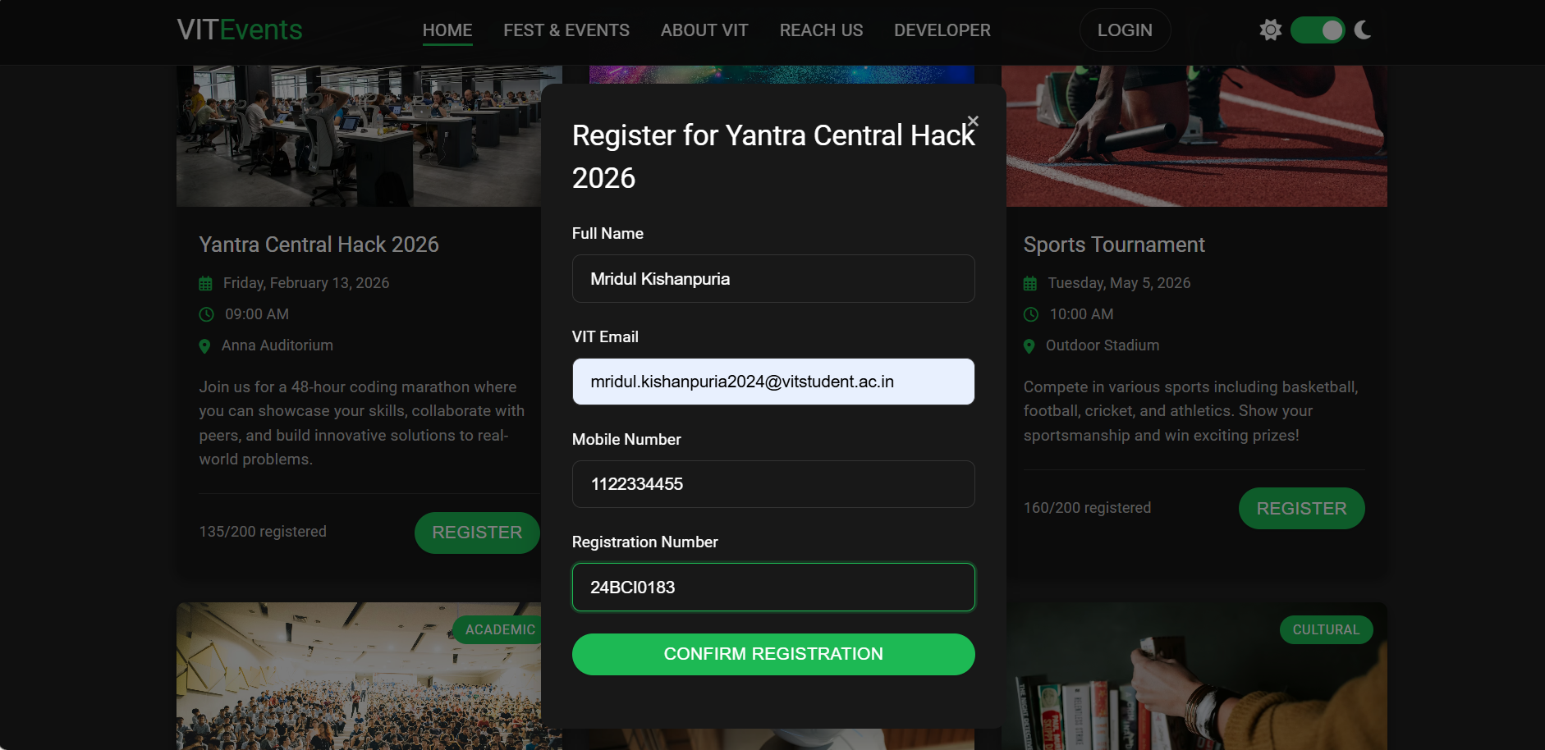
Screenshot of the Registration Modal
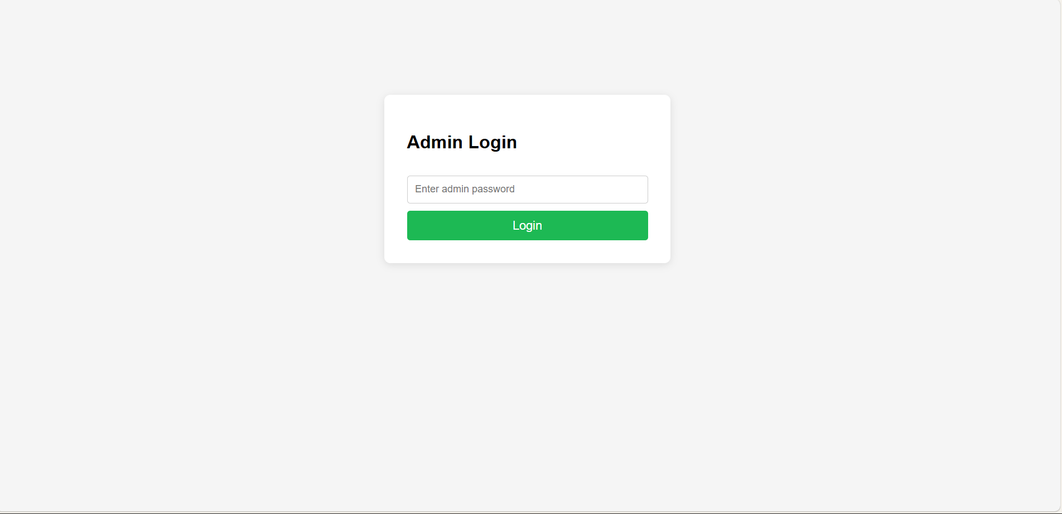
Screenshot of the Admin Dashboard

Conclusion
The VITEvents portal successfully achieves its goal of modernizing campus event management. By utilizing vanilla web technologies alongside a lightweight Google ecosystem backend, the project delivers a fast, responsive, and visually appealing solution. It eliminates the friction of decentralized forms, providing a unified hub that enhances the extracurricular experience for the student body.

Future Scope
- Database Migration: Transitioning the backend from Google Sheets to a robust database like MongoDB with a Node.js/Express framework.
- Authentication: Implementing secure JWT-based authentication and OAuth (Google Login) for verified institutional email access.
- Payment Gateway: Integrating a service like Razorpay to handle paid entry for premium hackathons or workshops.
- User Dashboard: Creating personalized profiles where students can track the events they have registered for and the certificates they have earned.

References
- Mozilla Developer Network (MDN) Web Docs - HTML, CSS, and JavaScript specifications.
- Google Workspace Developers - Google Apps Script Documentation.
- Material Design Guidelines by Google (UI/UX inspiration).
- Web Programming Course Materials, Vellore Institute of Technology.

